Computer System Design – Michael J Flynn

1 – Introduction to the systems approach

1.2 Components of the System
The implementation of a processor is known as the microarchitrcture – this includes things like branch prediction methods, shadow registers, ALU specifications, etc. This implementation is distinct from the architecture. The architecture is the user’s view of the system.

Heterogeneous computing contains multiple processors or cores of different types, each of these processors is suited for a particular and distinct purpose. This allows for higher performance under many scenarios. Generally each of these processors or cores has a distinct architecture, meaning different instruction set.

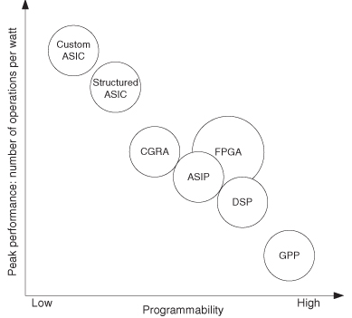
1.3 Hardware and Software
The best idea is to implement performance critical paths in hardware; if there is 10% of the software that takes up 90% of the execution time, a 10-fold speedup is achievable if that is implemented in hardware instead

Software on a general purpose processor and hardware on a custom ASIC are two extremes of a spectrum.

ASIP: Application specific instruction processors. A processor with an instruction set customized for a specific application or domain.

1.4 Processor Architectures
A superscalar processor is one that implements instruction-level parallelism within a single processor. A superscalar processor can execute more than one instruction in a single clock cycle; different instructions are dispatched to different execution units. This execution unit is some resource, such as an ALU.

Processors can be organized either by architecture approach or by application usage:
Processor Type | Application
GPU | 3-D graphics; rendering, shading and texture
DSP | Generic, sometimes used with wireless communication
Media Processor | Video and audio signal processing
Network processor | Routing / buffering

Processor Type | Architecture / Implementation Approach
SIMD | Single instruction applied to multiple functional units (aka processors)
Vector (VP) | Single instructions applied to multiple pipelined registers
VLIW (Very long instruction word) | Multiple instructions issued each cycle under compiler control
Superscalar | Multiple instructions issued each cycle under hardware control
Instruction level paralellism (ILP) can be achieved via many techniques (hardware, compiler or operating system); ILP means multiple operations can be executed in parallel. Loops with no data dependency are a prime candidate for parallel execution.
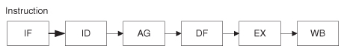
Sequential processors implement the sequential execution mode, executing instructions sequentially from the instruction stream.

An instruction is the smallest execution packet managed explicitly by the processor. There is a difference between instructions and operations; distinguishing between these two is essential to understanding different processor behaviors. Scalar and superscalar processors consume one or more instructions per cycle, where each instruction contains a single operation.

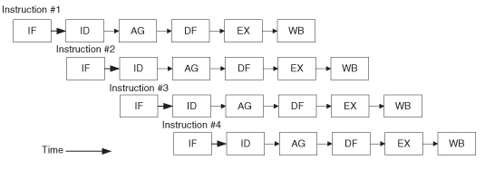
The inherent flaw in this design (stemming from its simplicity) leads to the pipelined processor which will concurrently perform different instruction processing phases. Some instructions may not require all stages / phases, but in the most rigid form of the pipelined processor, the static pipeline, all of these stages must be performed for each instruction. More complex dynamic pipelines allow instructions to complete or initiate out of order.

There are other techniques that can lead to executing multiple instructions at the same time (pipelining does not). These techniquies require some combination of static scheduling and dynamic analysis to perform the evaluation phase in parallel – this can potentially yield an execution rate of greater than one operation every cycle. This is called ILP.

Both superscalar and VLIW (very long instruction word) processors exploit ILP. These two types use different techniques to achieve execution rates greater than on operation per cycle.
Superscalar processors dynamically exampines the instruction stream and determines which operations are independent and can be executed in parallel. The VLIW processor relies on the compiler to do this organization / independent scheduling.

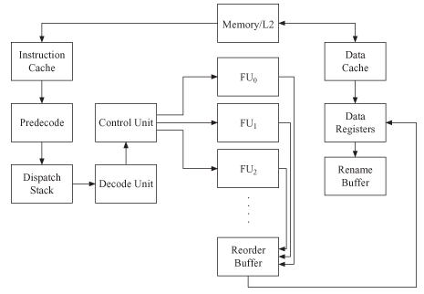
Superscalar processors
Multiple functional units and a dynamic scheduler allows for this to processor more than one instruction per cycle. The main advantage of this type is that the parallel processing is done transparently to the user. Because of the high complexity of this method, superscalar processors are only able to achieve four to six instructions per cycle.

VLIW Processors
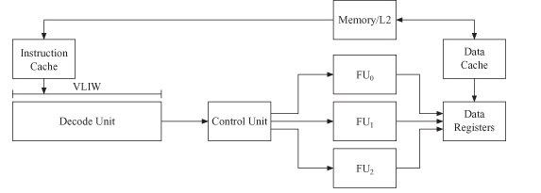
Relies on static analysis by the compiler. Less complex than superscalar processors and have potential for higher performance. The processor executes operations from statically scheduled instructions that contain multiple independent operations.
One downside of this method is that not all applications are able to take advantage of dynamic execution characteristics because they can not all be scheduled statically. The compiler can incorrectly predict how the machine will proceed, two different execution variations that affect scheduled execution behavior
- delayed results: the actual latency of operations differs from what the compiler predicted
- exceptions or interrupts cause interruptions which change the execution path to a different and unanticipated code schedule

SIMD Architectures: Array and Vector Processors
There are slight differences in implementation between array and vector processors. An array processor has many interconnected processor elements, each with their own local memory space. A vector processor contains a single processor that references a global memory space and has special functional units to operate on vectors. These processor types are both obtained by extending the instruction set of an otherwise conventional machine.

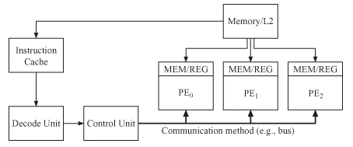
Array processors
An array processor is a set of parallel processor elements connected via one or more networks. There potentially can be local and global inter element communications and control elements between the processor elements. Each of the processor elements operate in unison via a single broadcast instruction from a control processor (SIMD). Each PE has its own private memory; data is distributed across the elements in a regular fashion that is dependent on the structure of the data and the computations to be performed. Because the instructions are broadcast, the PEs can not alter the flow of the instruction stream; individual PEs can however disable instructions based on local status info. An array processor is generally coupled to a general purpose control processor that provides both scalar operations and array operations that are broadcast to all processor elements. This control processor performs the scalar sections of the application.

To properly use an array processor, an application must have significant data that has a regular structure, computations on that data must be uniformly applied to many or all of the elements of the data set, and simple regular patterns relating all of the computations to the data. Any application with significant matrix computations is likely to benefit from the concurrent capabilities of an array processor.

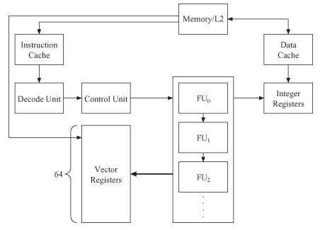
Vector Processor
Single processor that resembles a traditional single stream processor, but there are some function units (and registers) that operate on vectors; vectors in this sense are sequences of data that are seemingly operated on as a single entity. These function units are all deeply pipelined and have high clock rates; vector pipelines generally have higher latencies compared to scalar function units, but the rapid delivery of the input vector data elements with the high clock rates provide significant throughput.

In modern vector processors, there is a requirement that vectors are loaded into special registers and then stored back into memory. Most vector processors allow for result bypassing (aka chaining) that allows for follow-on computation to commence as soon as the first value is available from the preceding computation.
These vector processors have special ALUS that perform vector addition, vector multiplication and vector reciprocation.

Multiprocessors
Each processor executes completely independently, though generally applications require some sort of synchronization to allow for information passing during execution. Because the processors share memory and execute separate tasks, the implementation is significantly more complex.
When memory is localized to each individual processor, data sharing is performed via message passing, all synchronization is thus handled via the message system as well.
When communications between processors elements are performed through shared memory address space, there are two significant problems that arise
- Maintaining memory consistency: programmer visible ordering effects on memory references. Usually solved through a combination of hardware and software techniques.
- Cache coherency: the programmer invisible mechanism to ensure that all processor elements see the same value for a given memory location; this is generally solved exclusively through hardware techniques.

1.5 Memory and Addressing
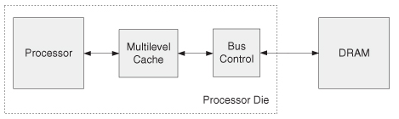
Because some applications need a whole bunch of memory, and putting memory on the same die as the SOC is expensive and has low bit density, the processor die model has evolved to allow multiple homogeneous processors to share off-die main memory.

If you are able to use only real memory, and that memory usage will be in the 10s of Mbs, then you can use a true system on a chip (all memory on a die).

1.6 System Level Interconnection
SoC tech normally relies on the interconnection of IP blocks (predesigned circuit modules). This raises the task of design from a circuit level to a system level.

SoC Interconnect methods can be classified into two approaches: buses and network-on-chip.
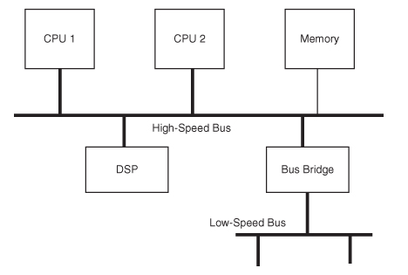
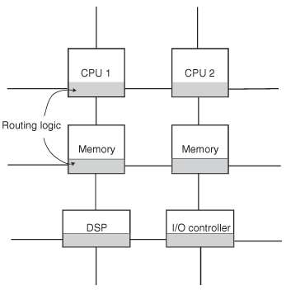

With a bus based approach, each of the modules conforms to a published standard such as AMBA (ARM’s Advanced Microcontroller Bus Architecture). Generally these buses are organized in a hierarchical fashion, like what is detailed in the image. The closer to the CPU the higher the bandwidth.

A network on a chip system consists of an array of switches; either dynamically switches such as a crossbar, or statically switched such as a mesh. A crossbar approach uses asynchronous channels to connect synchronous modules; these can operate at different clock frequencies. This has a higher throughput than a bus based system, it also makes integration of multiple clock domains easier.
In a simple statically switched network (such as the picture above to the right), each node contains processing logic for the core and its own routing logic; the interconnect scheme is based on a 2d mesh topology. All communications are performed through data packets, and each node routes these packets. Wire delay and cross talk are reduced sicne the interconnections have a fixed distance.

1.7 An approach for SOC design
Requirements and Specifications: The requirements are the largely externally generated criteria for the system: “I want it fast, cheap and now!” The specifications are quantified and prioritized criteria for the target system design. This initializes the design processes.
Design is always an iterative process.

This book is meant to assist one in determining the initial design. It does so by describing the range of processors, examples of requirements from various domains

1.8 System Architecture and Complexity
To grapple with complexity in system design, we reuse existing designs as much as possible.

1.9 Product Economics and Implications for SOC
IP comes in three different forms. Physical, where all of the very low level characteristics have been established and are unmodifiable, synthesized firm Ips that exist at the gate level, allowing for more optimizations and adaptability to different fabrication techniques; and synthesizable soft IP that exists on the RTL level – this allows for the end user to make some modifications

Chapter 2: Chip Basics: Time, area, power, reliability and configurability.
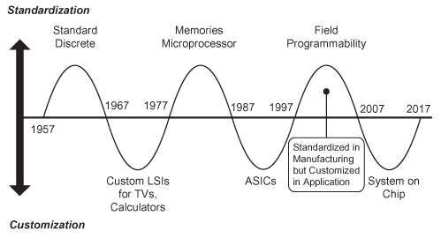
Makimotos’s wave is the observation that the circuit industry goes in waves of customization and standardization

Different applications demand different things. For example wearable devices demand low power, because power supply determines the system weight, but since these often have real time constraints as well, performance can not be ignored.

2.2 Cycle Time
Most actions are viewed in terms of cycle cound, but there are often unanticipated cycles from things such as cache misses. The shorter the cycle time, the more productive a pipeline – we will spend time analyzing how to partition instructions to achieve best results.

Clock cycle time is a fixed value in synchornous systems, and is determined by the longest time needed to do a frequent operation (such as adding two numbers). Less frequent operations can take up multiple clock cycles.

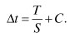
Clock skew is caused by the propogation delay of the clock signal; causing the clock to arrive later than the anticipated time. When we determine the optimal time for each segment (slice of an operation into a pipelined processor) we have to factor in this clock skew (and other things such as hold and set times of additional registers, together called clock overhead).

Incorrectly predicting branches (and other things such as cache misses) cause delays, which throws off the whole pipeline; all of the instructions already in the pipeline when this disruption happens need to be taken out of the pipeline. Even though the gate delay is decreasing, meaning that we can have more segmentation and minimize the C from the above equation, this only increases performance if we decrease the number of disruptions – the longer the pipeline the more a distribution throws the whole thing off.

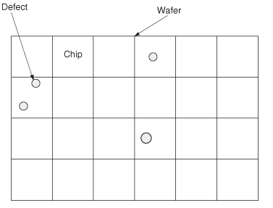
2.3 Die Area and Cost
SOCs generally have die sizes of about 10-15 mm on a side; the die is produced in bulk from a larger wafer that is perhaps 30cm in diameter. Defects randomly occur over the wafer surface due to imperfections in processing technologies; if chip areas are too big, the probability of defect in a chip goes up, meaning the yield is lower.

The area available to a designer is a function of the manufacturing processing technology.

A Poisson distribution is a discrete probability distribution; given a constant mean rate of independent events, this distribution predicts the probability of a given number of events occuring in a fixed interfal of time.
There are many different ways that the size, geometries and dimensions of physical transistor / system size; lambda is used as a dimensionless unit that the distance from one geometric feature on a mask to another; minimum feature size is used, which is the size of one poly-silicon gate; rbe (register bit equivalent) is the size of one six transistor register cell. The goal is to have some unit independent of the actual physical dimensions, since that is constantly changing.

Though transistor density is increasing, the wire delay benifts do not increase linearly at the same rate (as things get smaller, the gain in resistance offsets the smaller capacitance and length).
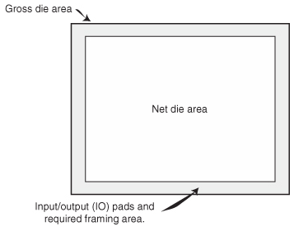
When thinking about the floor plan for any chip, we have to also consider the IO ports; this will take up some area all around the rest of the design (to communicate with pins on the outside). Certain elements need to be a certain shape, and we have to factor this into our floor planning – for example we want a more square shape to take full advantage of cache. Many times you do the initial floor planning with the things you for sure need, and this tells you how much cache you will have (that will be able to fit on your target die area).
In general the processor occupies around 20% of the total floor plan, while data; a majority of the area on a die will be dedicated to data storage.

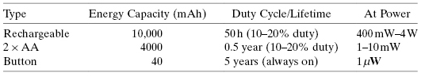
2.5 Power

Power dissipation is the most critical issue for portable applications (things running on batteries). Power optimized implementations use less chip area because of power supply requirements, clock distribution requirements and reduced performance targets.
For battery powered SOC designs that are expected to run for an extended period, power consumption must be on the order of milliwatts. You also need to examine the peak power and verify that a particular source can provide a certain current at the specified voltage.

2.7 Reliability
As die area increases, the amount of circuitry, and thus the probability of fault, increases as well. Higher die area allows allows for techniquies such as ECC to be implmeneted. Faster circuits are smaller and more suseptible to radiation.k

2.8 Configurability

3 – Processors

Intro
The vast majority of processors produced on a given year are 4 and 8 bit microprocessors used for embedded systems (70% of total). The demand of SOCs is growing at almost 3x that of other mpus.

When we look at the performance of a system, we simply consider interconnects as a time delay component; we need to have a conservative estimate of its performance.

3.2 Processor Selection
Simply doubling the performance of a processor will also double the cache miss rate per unit of time, this means to recover lost performance you have to increase the cache size. The general rule to half the miss rate is to double the cache size.

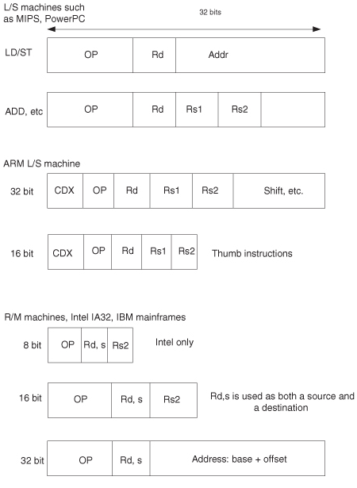
3.3 Basic concepts in processor architecture
There are two main types of processor architectures:

L/S (Load-store) which requires arguments to be in registers before they can be used. This has regularity in execution and simple instruction decode; it is easily implemented

R/M (register – memory) architecture which has instructions that can operate on operands in registers or with operands in memory. This allows for higher code density at the expense of more complex decoding. Because of the higher complexity, these require more circuitry (and thus area) to be devoted to fetch and decode.

ARM is L/S but with an interesting compromise, having a built in conditional field for all instructions and having a 16 bit instruction set called thumb.

3.4 Basic Concepts in Processor Microarchitecture
Every processor has a memory system, execution unit (data paths) and an instruction unit (control of cache and execution unit).

Pipeline delays and breaks:
- Data conflicts – the next instruction requires the result of the previous
- Resource contention – Multiple successive instructions need to use the same resource
- Run on delays – Instructions that must complete the write back in program order
- Branches – The pipeline is delayed because of branch resolution

3.5 Basic elements of instruction handling

4 – Memory Design: System on chip and Board based systems
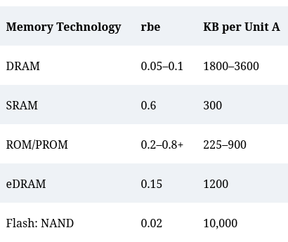
4.1 Intro
Memory design is the key to system design

You should base the memory size / technology based off of application requirements, the operating system and the data that will be used.

If memory is contained to on-die memory, access time can be limited to 3-10 cycles; having data off chip will be much slower (30-100 cycles). The achieve the same performance with on and off die memory, you must have much more cache.

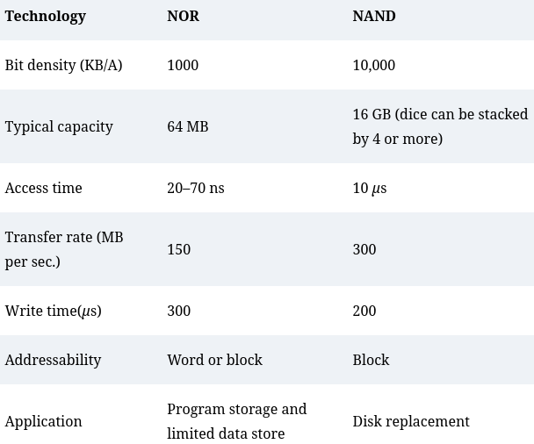

4.2 Overview

Flash die can be “stacked” with an SOC chip to present a single package with system and memory

The memory system is limited by two basic parameters; access time (time to send request, access datum, and return the result back) and bandwidth (number of requests serviced per unit of time).

4.3 Scratchpads and Cache Memory
Small, fast memory that is easily accessible (one cycle) is called scratchpad memory if it is managed by the programmer; if this memory is managed by the hardware it is called cache

Because mangement is cubmersome, most general purpose computers use only cache. On an SOC though, if the application is well known, the programmer can explicitly control data transfers for use. An SOC usually has scratchpads for data and not for instructions.

Caches operate on the assumption of locality, and there are three principles.
Spatial locality; Given an access to a particular location in memory, there is a high probability that access will be made to that location or a neighboring one.
Temporal Locality; given a sequence of instructions, there is high probability that they will access the same location.
Sequantiality; if a reference is made to location s, it is likely that within the next few references, s+1 will be referenced.

4.4 Basic Notions
A processor-cache interface has a number of parameters
physical word – the unit of transfer between the processor and cache
block size – aka line; the basic unit of transfer between cache and memory
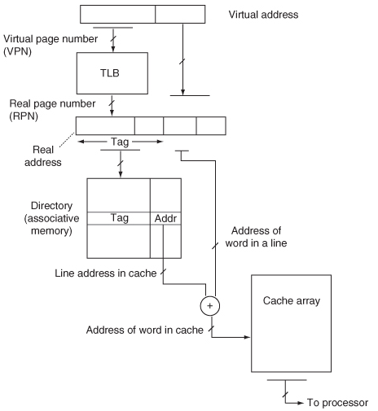
access time for a cache hit and cache miss

4.5 Cache organization
Cache can either use fetch-on-demand or prefetch strategies. Prefetch is commonly used for I caches.

There are three different types of cache organization; fully associate, direct mapping and set associative mapping (which is really a combination of the other two).

For a fully associative, when you request an address, the address is compared to all addresses in the cache. For a fully associative cache, the actual physical address is not encoded in the memory access; the accessed memory address is looked up in a table and that result is used to find the location in memory.

With a direct mapped cache, the requested address shares the upper set of bits with the actual address.

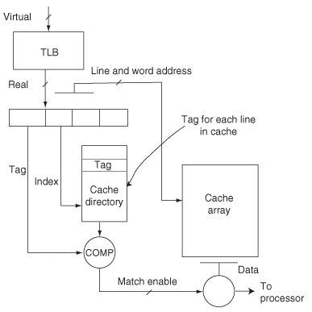
A set associative cache is a combination of the two, where each upper address decodes to a set of cached addresses; very similar to a direct mapped, but each tag can refer to a set of caches.

4.6 Cache Data

4.7 Write Policies
Write through: write to both memory and cache on each write. The advantage here is you coherency between memory and cache, but the disadvantage is high memory bandwidth.

Write back: write only to cache, memory is updated when the line is replaced. We have to keep track of dirty lines for this approach.

Most larger caches use copy back (aka write back).jj

4.8 Strategies for Line Replacement at Miss Time
When we replace something in cache with something in memory because of a cache miss, we may have to write the element from cache out to memory first (if we are using a write/copy back write policy).

Nonblocking cache aka prefetching cache allows for control hardware to handle the cache miss while the processor continues to execute. This only works when the miss is for something not currently required by the processor. These perform best with compilers that provide prefetching.

Line replacement policy when cache is full can be something such as LRU,, FIFO, RAND.

Operating systems tend to slightly increase the miss rate experienced by a user program (20% or so).

Multiprogramming enviornments have special demands on caches, and simply increasing the size of a cache may not increase performance for these models.
There are two multiprogramming enviornments
- Multiprogrammed: the system, along with other programs, are resident in memory. Control is passed from program to program after some time period or number of instructions. This results in a warm cache that tfinds that some but not all of its most recently used things are in cache
- Transaction processing: while the system is resident in memory with a number of support programs, short applications (called transactions) run through to their completion. This is called a cold cache

4.9 Other types of cache
The most popular configuration of partitioned caches is splitting instructions and data into their own caches. This method provides significantly increased cache bandwidth, but results in a higher miss rate. With a unified model, the replacement policy adapts as the program switches between instruction or data heavy.

4.11 Multilevel Caches
A cache is implemented from SRAM cells, and as the array increases in side the length of wires increases. As the length of wires increase, the higher the cache access delay. Cache access delay is determined from feature size f (process technology), cache capacity C and the degree of associativity A
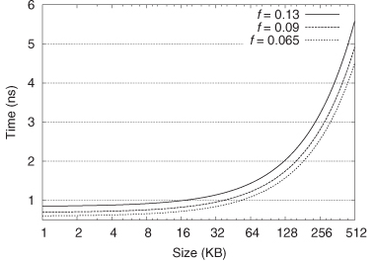

This causes L1 caches to generally be less than 64K, L2 usually less than 512K and L3 being multiple arrays of 256K.

In a multi level cache, the cache is called “inclusive” if all of the contents of the lower level cache (L1) are contained in the higher level cache (L2).

When accomidating for multiple levels, the line size of the second level cache should be the same size as the first level cache; if they are mismatched, a miss could result in more than one miss (because the line size is bigger and needs two lines to represent).
When we do analysis of the cache, we can simply analyze the miss rate of the larger cache, since the cache is inclusive.

4.12 Virtual to Real Translation
The TLB provides the real addresses by translating virtual addresses.

TLB access in many way mimics cache accesses; if an entry is not in the TLB then it is a TLB miss, which is costly. Generally four way set associative caches are used for TLB.

If a cache uses real addresses, but you are using virtual addressing for the system, a TLB access must occur prior to cache access.

4.13 SOC (on die) Memory Systems
When implementing all memory on die, the designer has greater flexibility in the selection of memory itself and the overall cache-memory organization.

Deep reactive-ion etching is a etching processes that creates deep penetration holes in wafers and substrates. It can be used to create high density capacitors for DRAM, called deep trenched capacitors. A substrate is placed inside of a reactor, several gases are introduced and plasma stuck in the gas mixture breaks gas molecules into ions. This ions accelerate towards the etched material on the surface.

For a stand alone die, SRAM is 10-20 times faster and 10 times less dense than DRAM. This is because of DRAM being designed to use few wiring layers (for density), low refresh rates (low leakage currents) and using nonminimum length transistor with a higher threhold voltage.

eDRAM is a compromise for use as on die memory. There are additional process steps to realize and SOC with eDRAM. The process complexity for eDRAM is increased because it may require up to three additional mask layers, resulting in 20% more cost than DRAM. The advantage of eDRAM is its higher density. The cycle (and access time) of eDRAM is much better than traditional DRAM.

SRAM cells are faster and easier to flip, resulting in higher single bit error rate; as SRAM technology scales, the supply voltage decreases and the amount of charge for determining errors decreases as well.

4.14 Board Based (off die) memory systems
The memory module is all of the memory chips needed to forward a cache line to the processor via some bus. The cache line is tranmitted via a series of word transfers.

Module access time is the amount of time required to retrieve a word into the output memory buffer register of a particular memory module. The total time for the processor to access a line in memory, gtenerally no more than the chip acess time in a simple small system.

Memory service (or cycle) time is the minimum time between requests directed at the same module.

SDRAM (syncrhonous dram) was the first major improvement of DRAM tech; it synchonizes the dram acess and cycle time with the bus cycle.
DRAM: Asynchronous dram
SDRAM: Memory module timing is synchronized to the memory bus clock
Double Data Rate (DDR) SDRAM: The memory module fetches a double sized transfer unit for each bus cycle and transmits at twice the bus clock rate.

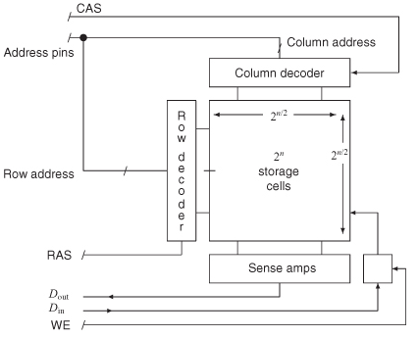
4.15 Simple DRAM and the Memory Array
The simplest async DRAM is a single memory array with 1 output bit. Internal to the chip is a two dimensional array of memory cells consisting of rows and columns. The cell that is referenced is simply a MOS transistor holding a charge (as capacitance). The capacitors are continually refreshed over time.

The sense amp will amplify the output signal to the dout pins. First the row address is given to the chip, then using the same pins, the column address is given. Dout is at high impedance until the data is actually placed on the bus.

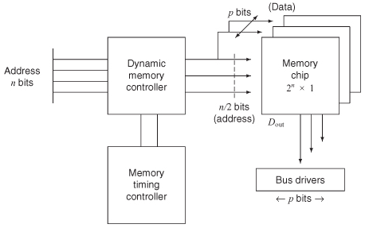
A DRAM module also consists of the actual memory chips, dynamic memory controller and a memory timing controller. These three pieces multiplex the input address to the row and column addresses, drive the RAS and CAS signals to the memory arrays and provide timing to refresh the memory system.

There is also a need for a buffer that will store the p bits read from the memory chips; this is directed at bus drivers that interface to the memory bus. This memory bus is the inferface for all memory modules.

There are two “burst” mode type features in DRAM chips that are called: nibble mode and page mode. Both of these improve the transfer rate of memory words; nibble mode basically it sequentially reads through a word by toggling one column and then the next. In page mode a row is slected and then an arbitary set of column addresses are quickly toggled; usually enough to fill the cache line.

SRAM and DDRSRAM.
SRAM as mentioned was the first major improvement to DRAM, it syncronizes the DRAM access and cycle to the bus cycle. This eliminates the need for seperate memory clocking chips for RAS and CAS signals. The package was also extended to accommodate for multiple output pins. This was further improved by using differential address and data lines.

With DDR this was improved even more by using two clocks that toggle opposite of each other; so when the one clock is high, the opposite clock (called the compliment) is low, and vice versa.

Processors generally have some queue depth limit; the highest number of outstanding transactions they can handle at a time, this lowers the total bandwidth of the memory. Logical dependencies on data from memory can also pause program execution; if the result of something from memory will cause a conditional branch.

4.16 Models of Simple Processor-Memory Interaction
When you have multiple processors all trying to access the same memory element, yiou can rrun into contention where one or more of them has to wait. A processor with nonblocking cache making tons of requests to the same module can cause this same contention. We should be able to model both of these scenarios in the same way

We can model this with Bw = B(m, n) / Ts; where Bw is the number of requests serviced per unit of time, B(m, n) is the number of requests and Ts is the unit of time. B(m, n) will come from the cache miss rate.

The Strecker-Ravi model is the original model for making n processor requests per memory cycle per m memory modules.

4.17 Conclusions
Cache gives you significantly faster memory access time.

Chapter 5 – Interconnect
In a NOC, the switch can either be a cross bar, directly linked interconnect or a multistage switching network. In this text, units is used in place of nodes or agents (things being linked together). This text simply provides a simplified overview.

5.2 Overview – Interconnect Architectures
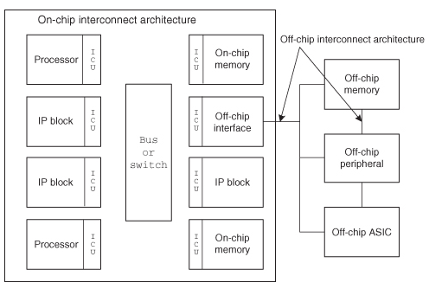
A NOC is
- More than a single shared bus
- Something that provides point-to-point connections between two hosts attached to the network through some sort of switch
- Provides high aggregate bandwidth through parallel links
- Communication is seperate from computation
- Uses a layered approach to communications
- Support pipelining and provide intermediate data buffering between sender and receiver

IP Blocks communicate with one another through the interconnect; the interconnect is accessed through the interconnect interface unit (ICU). This is a common interface for all modules.

To correctly choose the interface, you need to have a good understanding of the
- Communication bandwidth: rate of information tracnsfer between a module and the surrounding env; usually in bytes per second
- Communication Latency: Time delay between a module requesting data and getting the response. The importance of this depends on the application – for media steaming it doesn’t matter much, but for two way communication it is crucial.
- Master and Slave: can a unit initiate or only react to communication requests? SOC designs generaly have several masters and a few slaves.
- Concurrecnt requiremrnt: How many parallel communication channels are needed?
- Packet or Bus Transaction: The size and definition of the info transmitted in a single transaction
- ICU: Out of order transaction buffering? Protocol translation (if the design needs it, it is called a bus wrapper)? Manages the protocol for transport ofa packet from the IP core to the switching network.
- Multiple clock domains: Different IP modules may operate at different clock and data rates. Clock domains are separate timing regions. Crossing between clock domains can cause deadlock and synchronization problems without careful design.’

5.3 BUS: Basic Architecture
All system level buses are designed to drive a backplane, and are thus not very suited for SOC technology. Bus architecture of this type has three main constraints; the number of signals is limited by the number of pins; the speed of the bus is limited by the high capacitive load on each bus signal, the resistive contacts of the connector and the EM noise produced by fast switching signals; drivers for on chip busses can be much smaller.

From a high level, a bus is just wires shared by multiple units. Some logic must be present to make sure the bus is used in an orderly fashion.
Ownership of the bus is determined by arbitration; in a simple design, there is a centralized arbitration unit.

The bus protocol is an agreed set of rules for transmitting info between two or more devices on a bus. This protocol determines
- type and order of data being sent
- how the sending devices says it has finished sending
- data compression used (if any)
- how the receiving device acks it got the message
- How arbitration is performed

A bus bridge is a module that connects two buses together. These buses don’t have to be of the same type. This allows both buses to operate at the same time; it acts as a statndard communication method between the two buses. There is generally a buffer for which data is stored before it is passed between the two buses. The bus bridge can significantly improve system performance.

Buses can be either unified or split: meaning the address and dataare transmitted on the same bus cycle or on two separate cycles. Buses can also be either single transaction or tenured. Tenured buses have a transaction only during associated addresses or data cycles. These buses have recivers that buffer the messages and create sepereate data and address transactions.

5.4 SOC Standard Buses

AMBA was introduced in 1997. It has two levels of hierarchy. There are two buses defined in the AMBA spec.
- Advanced High Performance Bus (AHB) connects embedded processors to high performance peripherials, DMA controllers, on chip memory and interfaces. High speed, high bandwidth bus; uses seperate address, read and write buses. Operations can range from 32-1024 bits. All transactions are referenced to a single clock edge.
- Advanced Peripherial Bus (APB) has lower performance than AHB but is optimized for minimal power consumption and reduced interface complexity.
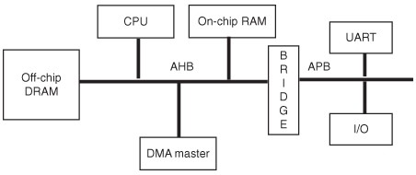
AMBA attempts to supply the user with
- Module design and design reuse.
- Well defined interface protocol, clocking and reset
- Low poer support
- On chip test access

AMBA AHB is not a tristate implementation; it provides higher performance and lower power than using tristate buffers

Transactions on AHB follow three steps
- Bus master obtains access (master issue request signal, arbiter selects)
- Master initiates transfer (drives address and control signals)
- Bus slave provides a reponse

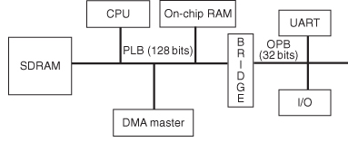
CoreConnect Bus is from IBM and is an SOC bus standard around powerpc (though is also adaptable to other processors). Also has bus heirarchy and supports mutliple master and other features AMBA has. There are three buses: processor local bus (PLB), on-chip peripheral bus (OPB) and device control register bus (DCR).
The PLB is used for high bandwidth, high performance and low latency connections

A particular IP core may have been compiled with one particular BUS standard and thus cannot be used with another in an SOC design. A socket can be employed to solve this issue; a bus wrapper that allows the module to talk to any physical bus type. Virtual Socket Interface Alliance (VSIA) proposes a set of standards and interfaces called virtual socket interface (VSI).

5.5 Analytic Bus Models
Contention occurs when two or more units request a shared resource that cannot be supplied to both at the same time. In repsponse to this, the unit can either wait or queue up the request and continue on doing other things.

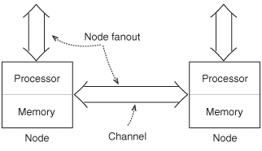
The most limiting resource in a system is the source of contention; if memory is slowest it is that, if the bus is the slowest, it is that.

Doing calculations of simple systems without re submission is simple; you can just calculate how often the CPU is waiting on the bus to complete its operations (ratio of cpu processing time + bus time to bus time alone)

There are both blocking and non-blocking transactions; for blocking transactions the processor is idle after the request is made, until the response is given; non-blocking transactions buffer the operation but are much more complex.

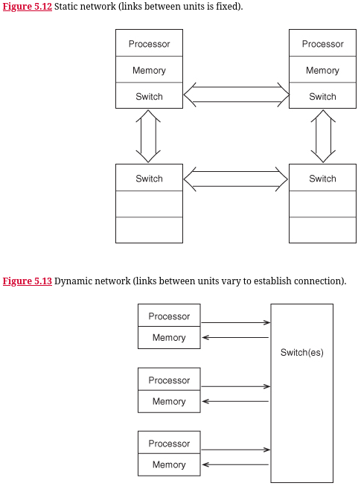
5.6 – Beyond the BUS: NOC
Even a well designed bus can suffer from data transfer bottlenecks; buses are also not scalable as more modules are added. Switches are also more more complex than buses though; though a large number of nodes can be connected with low latency, each node increases the cost exponentially.

In current SOC designs, NOCs are generally limited to 16-64 nodes due to die size.

The fanout of a node is the number of bidirectional links it has connecting it to other nodes.

In static networks, the topology (aka the relationship between nodes in the network) is fixed. In a dynamic network, the paths between nodes can be altered both to establish connectivity and improve network bandwidth.

A static network might be a 2D grid of switches, whereas a dynamic network might have a centralized crossbar switch (see figure).
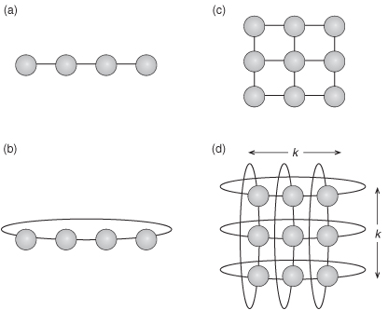
Static Networks
the distance between two units is the smallest number of links or channels (or hops) that have to be traversed for establishing communications.
The diameter of the network is the largest distance without backtracking.
A closed network is something like a rink, it improves distance and diameter (b). (d) is the most common kind of network, known as a (k, d) network, it can be of various dimension.
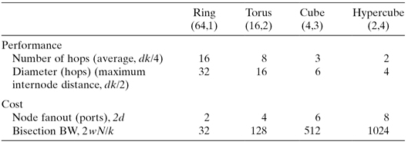
We can increase links in a network by increasing the dimensionality of the network.

Bisection bandiwdth refers to the number of wires intersected when a network is split into two equal halves.

Links are characterized by:
Cycle time of the link Tch: time required to transmit a message to a neighboring node
The width of the link w: number of bits that may be transmitted at a time.
We also factor in the length of the message and the size of the header (destination address).

Wormhole routing is a track in which a message is buffered only long enough to decode the header and determine the destination; then the message is retranmitted.
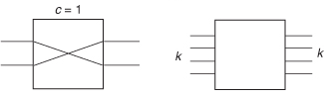
Dynamic Networks
Generally the basic element of a dynamic element is a crossbar switch. A crossbar connects one of k points with any of another k points.
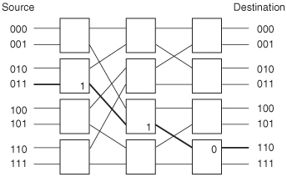
You can use a crossbar as the basis for a multistage network, often known as a multistage interconnection network. It uses multiple stages to create the proper connection path between two nodes. Often time addresses can be given in the form 110, meaning that at the first node, take path 1, at the second, path 1, at the third, path 0 (assuming there are two options at each switch).

5.7 – Some NOC Switch Examples
GALS: Globally Asynchronous, Locally Synchronous

5.8 – Layered Architecture and Network Interface Unit
The network interface unit is a key component in the NOC; it allows the NOC to overcome limitations in a traditional bus based approach.
The fundamental weakness of buses is that they do not take a layered approach to interconnection: no explicit separation between transaction level communication in the applications layer and interconnect signals in the physical layer. (packet/ message based routing?)
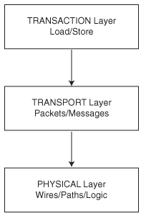
NOCs allow for separation similar to the networking stack (L1/L2/L3, etc). The area ocerhead of network logic can be as low as 6.6%.
NOC architectures have
- a layered architecture that is easily scalable
- flexible switching topology that can be configured by the user to optimize performance for different applications
- point to point communication that decouples IP blocks from one another.

The physical layer is how packets are transmitted over the physical interfaces. Switch structure, clock frequency and other process technology changes only affect this layer.
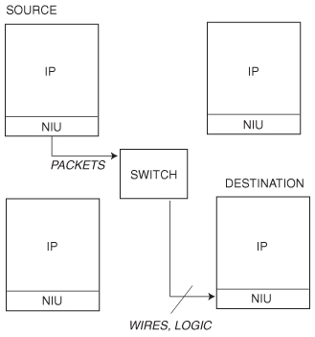
The transport layer defines how packets are routed through the switch network. A small header in the packet is generally used to specify routing. This layer defines the communication primitives used to connect IP blocks in the network. The NIU provides the transaction level services to the IP block.

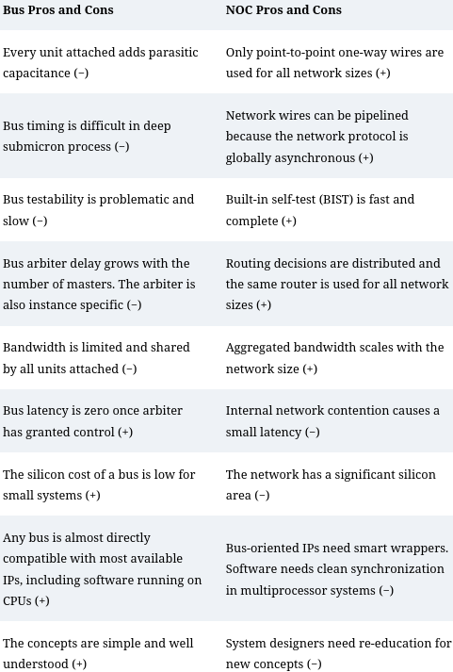
5.9 – Evaluating Interconnect Networks

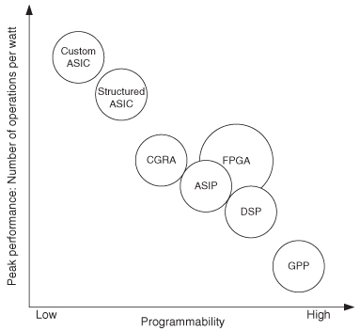
Chapter 6 – Customization and Configurability
6.1 – Intro
Structured ASIC allows for limited customization before fabrication, compared with a custom ASIC.

Though there are many many ways to customize SOC designs, this chapter focuses on three of those
- Customization of instrucitno processors
  - Processor families
  - Applications specific processors
- Reconfigurable fabrics
- Customization techniques for optimizing implementations

6.2 – Estimating Effectiveness of Customization
The effectiveness is both from how much of the design is configurable and also to what degree is that configurable part configurable.
(1 – B) + A * B

Coarse-grained elements can implement a specific function more efficiently than fine-grained programmable logic. However, since they are not as flexible, they only benefit applications which utilize them.

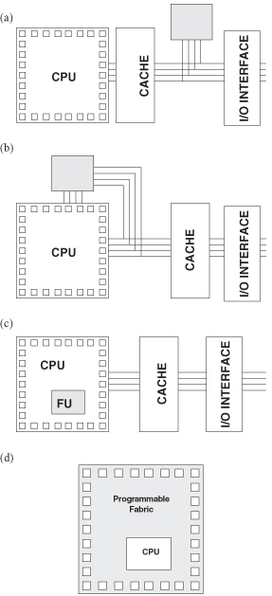
There are, however, several reasons against customizability. Tools for customizable processors such as performance profilers and optimizers are often not as mature as those for noncustomizable processors;

6.3 – SOC Customization, an overview
CPLD: Complex programmable logic device

a) attached processing unit
b) co processor
c) configurable FU – the processor and the fabric are tightly coupled here; perhaps this embedded FU provides custom instructions. The Stretch Software configurable processor was the first to do this fort of thing.
d) processor embedded in reconfigurable fabric

There are also programmable analog devices, that can be configured as combincations of comparators, filters and A2D

6.4 Customizing Instruction Processors
The first main approach is to provide familes of customized processors. ARM has this sort of thing to some extent: they have the A series for intensive applications, R series for real time and M series for microcontrollers in embedded applications.. All of these series have some different characteristics.
The second approach is to allow the user to configure the processors by generating customized processors. You can remove features you don’t need and add features you do; custom instructions allow for optimization.

There are Domain Specific Languages for architecture and processor description. The goal of these is to allow the features of a customized processor to be written in a high level and then automatically generated.

Behavioral Descriptions for architecture specific languages allow a designer to specify an instruction set, and then there are tools to automatically generate compiler, assembler, etc. nML and TIE are languages that fall into this category. The advantage is the high level of anstraction, all that it needs is the instruciton set and the tool does the rest; The disadvantage is the lack of flexibility since everything is inferred from the IS.

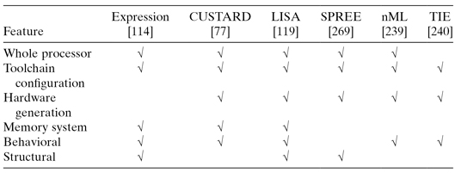
Structural Descriptions capture the FUs, storage resources and interconnections of a processor. Most of these types of descriptions maintain the generality of a hardware description language, it also allows much more scope for describing various micro-architectures. The disadvantage is the low level of abstraction.

To the right is a table of some modern architecture description languages.
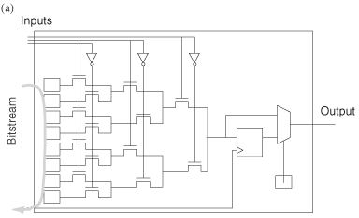

6.5 Reconfigurable Technologies
Reconfigurable techonologies can be more or less configurable, the more configurable, often the slower and larger the parts are.

A fune grained FU can typically implement a single function on a single (or small number) of bits. The most common kind of fine grained FU are the LUTs that implement the bulk of FPGAs.
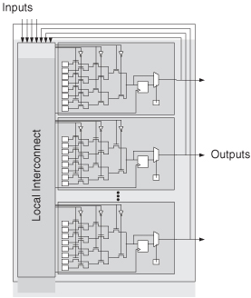
LUTs typically have 3 to 6 inputs; by shifting in the correct number of bits, LUTS can implement any function with those three inputs.
LUTs are combined into Clusters, depending on the vendor, these have different names: Altera calls them “logical array blocks” (LAB), whereas Xilinx calls them “Configurable logic blocks” (CLB).
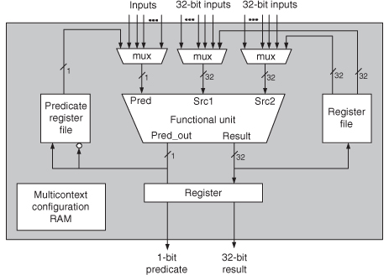
Fine grained FUs implemented from LUTs can implement any circuit, but they use up more area, time and power than a coarse grained structure. Because of this, FPGA companies often add additional features for common operations such as arithmetic. Because thse structures are in fixed locations, it can make routing and congestion more of a problem.

A coarse-grained FU is usually much larger [than a fine grained FU] and may consist of ALUs and even storage. Instead of Clusters and LUTs, these devices might have blocks with ALUs, Memory and a register file.

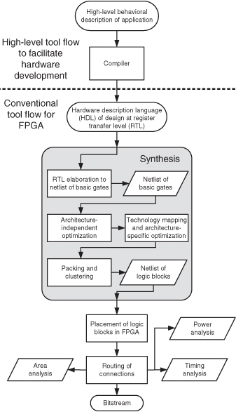
Regardless of being fine or coarse, FUs need to be connected in some way; the same trade off with flexibility/power/area remains in the interconnect. Generally Fine grained devices like FPGAs also have a fine grained interconnect; generally the FUs are arranged in a grid pattern

6.6 Mapping designs onto Reconfigurable Devices
A hardware engineer writes HDL in something like VHDL or Verilog. This is converted into a description of the circuit in the register transfer level (RTL) (specifies the operations at each clock cycle). This is then synthesized to a netlist of logic blocks. These logic blocks are then placed and routed on the FPGA.

In the first stage of synthesis, datapath operations from the RTL such as control, memory, registers,adders and multipliers are “identified and elaborated into” basic boolean logic gates.
Then there is architecture independent optimization, this will optimize the netlist of basic gates by minimizing the boolean expressions, removing redundant logic, sharing buffers, retiming, encoding finite state machines.
These basic gates are then mapped to the particular technology to take advantage of things like adders and shifters that the fpga provides.
The final stage of synthesis is then to pack and cluster groups of luts into the logic blocks (CLBs, etc).

Then, after synthesis, the blocks are placed on the FPGA for particular goals. Then the connection of IOs, logic blocks, and embedded elements are routed

6.7 Instance Specific Design
The aim of instance specific design is to optimize an implementation for a particular computation.

6.8 Customizable Soft Processor
CUSTARD is a soft core processor that can be tailored to your exact environment. Mutlthreaded applications can benefit from this soft core significantly; each thread is even its own hardware resources (registers, stack pointer, etc), which makes context switching take only a single cycle. Additionally, if a multi threaded method called Interleaved Multithreadding (IMT) is used, the processor will switch between the two threads every instruction; the benefit of this is that all look-ahead type functionality can be removed, meaning that the pipeline will never encounter hazards. CUSTARD also allows for custom instructions to be implemented. The application and the processor are compiled together.

6.9 Reconfiguration
Often times reconfiguration can be done during runtime; say you have a small FPGA and a few different functionalities that you want to be implemented in soft hardware; you can have different bitstreams for those different functionalities and load them. You have to do an analysis of the possible speedup and time needed to reconfigure the device; if the time to reconfigure the device is longer than the original time to do the operation in a GPP, what’s the point? Additionally if you have a algorithm that has many steps, perhaps you can reconfigure the FPGA in between each of the steps, if it is worth it time wise.

Chapter 7 – Application Studies

7.3 AES
AES has three block sizes: 128, 192 and 256. The process from original data → encrypted data has: one initial round, r-1 “standard” rounds, and one final round.

There are four major steps in each round.
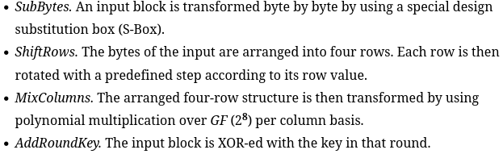

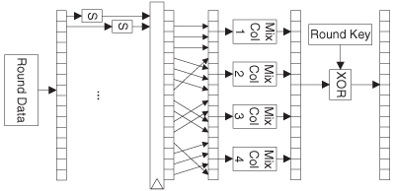
The first round is only the “round key” step. Standard rounds consist or all 4 steps. The “Mix columns” round is removed in the final.

7.4 Graphics

Chapter 8 – What’s Next
ASOC (autonomous system on chip): convergence of RFID with SOC coupled with transducers and sensor controllers, and batteries, all on the same die.

Transducer: a device that converts energy from one form into another, generally used for sensors, such as something that converts potential mechanical energy into potential electric energy.

Microelectromechanical systems (MEMS): very very small mechanical devices that are created using the same technology that is used for chip manufacture.

8.2 Overview of ASOC
Autonomous chips (Acs) are a fast growing chip marketplace. They have little processing power or memory, but have RF communications and some sort of self-contained power source. RFID chips, smart cards and chip-implenated credit cards are examples.
A passively powered RFID is a chip that reflects the source RF carrier and modules it (using power from the carrier); this modulated reflection indicates the ID of the chip.

Java Card is software technology that allows Java bassed applications (called applets) to run on smart cards.
Smart Cards are electronic authorization devices; there is an embedded integrated circuit. Some use a metal pad to connect to the internal chip, others are contactless; smart cards can provide personal identification, authentication, data storage and application processing.
The SIM Card from phones is a type of Smart Card.

ASOC is a combination of this AC and SOC technology. Obviously to do something like this, the system needs to be implemented to use very very low power; in the sub-microwatt region.

An ASOC being able to process data, means that less data has to be transmitted.

8.3 ASOC Technology
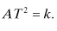
With very very small manufacturing arises problems; the dopant variability (number of dopant atoms needed to create a device) causes variability in delay from device to device.

He reminds us of a approximate relationship between the area (number of transistors) of a chip, and the time needed to execute an algorithm: the more transistors, the faster the algorithm can be executed.
Doubling the frequency of a design would require eight time as much power

With RF there is some sort of “Spatial and temporal” synchronization that needs to take place with all communications, which results in a very large header.

